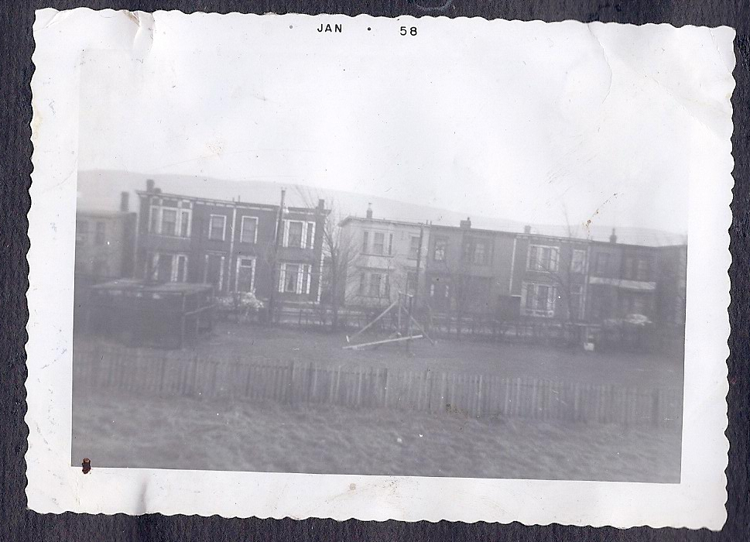

the grounds of 106 Pennywell Road, from the hill looking south

3/4 – Thistle Yard in foreground, Green Gate behind
pine hatchery to the left, swings and seesaw in centre
houses of Pennywell Road behind

